**Assignment 10.2 Sqoop**

**Problem Statement:**

**Mentioned all the steps:**

[**https://acadgild.com/blog/loading-data-into-hbase-using-pig-scripts/**](https://acadgild.com/blog/loading-data-into-hbase-using-pig-scripts/)

**DataSet:**

**StudentName, Sector, DOB, qualification, score,state, randomName.Step1:**

**HDFS**

**hadoop fs -put Downloads/student.txt pighbase/**

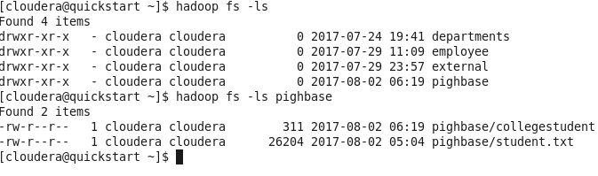

**Step 2:**

**Hbase shell:**

**create 'student_new' , 'studentdetailnew'**

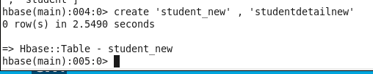

**Step 3:**

**pig**

**a= load 'pighbase/student.txt' using PigStorage (',') as (StudentName:chararray,sector:chararray,DOB:chararray,qalification:chararray,score:int,state:chararray,randomName:chararray);**

**dump a;**

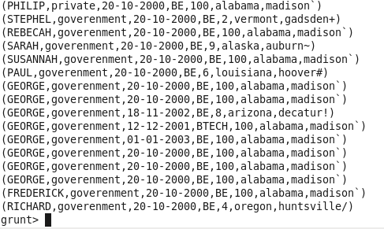

**Execute Belwo command on grunt shell:**

**STORE a INTO 'hbase://student_new' USING org.apache.pig.backend.hadoop.hbase.HBaseStorage(**

**'studentdetailnew:StudentName**

**studentdetailnew:sector**

**studentdetailnew:DOB**

**studentdetailnew:qalification**

**studentdetailnew:score**

**studentdetailnew:state**

**studentdetailnew:randomName'**

**);**

**Hbase**

**Describe 'student_new'**

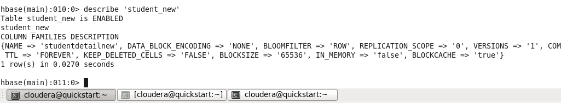

**scan 'student_new'**

